Brief on git commands: Rebase, Stash, Tagging, Reflog
Git Rebase: The git rebase command is used to transfer commits from one branch to another. This command creates a clean and linear history by 'moving' or 'replaying' your changes onto the most recent state of a destination branch, usually the main or trunk branch.

- I created a feature branch that I called My-branch from the main branch.
- Once I had made some changes and committed them, I decided to update My-branch with the latest commits from main.
- Instead of running git merge, I used git rebase main, which creates a clearer history without unnecessary merge commits.
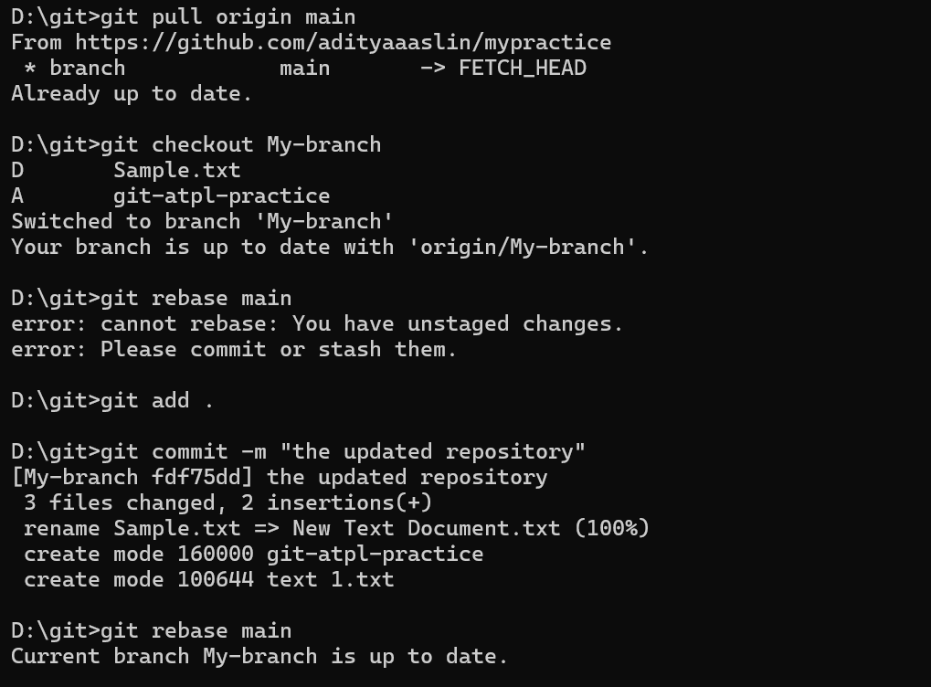

Git Stash: The git stash command is used to store unfinished or uncommitted changes to your working directory temporarily. It provides a way for you to clean the workspace you are working in, without committing it. This allows you to safely change branches or pull without losing any of your changes.
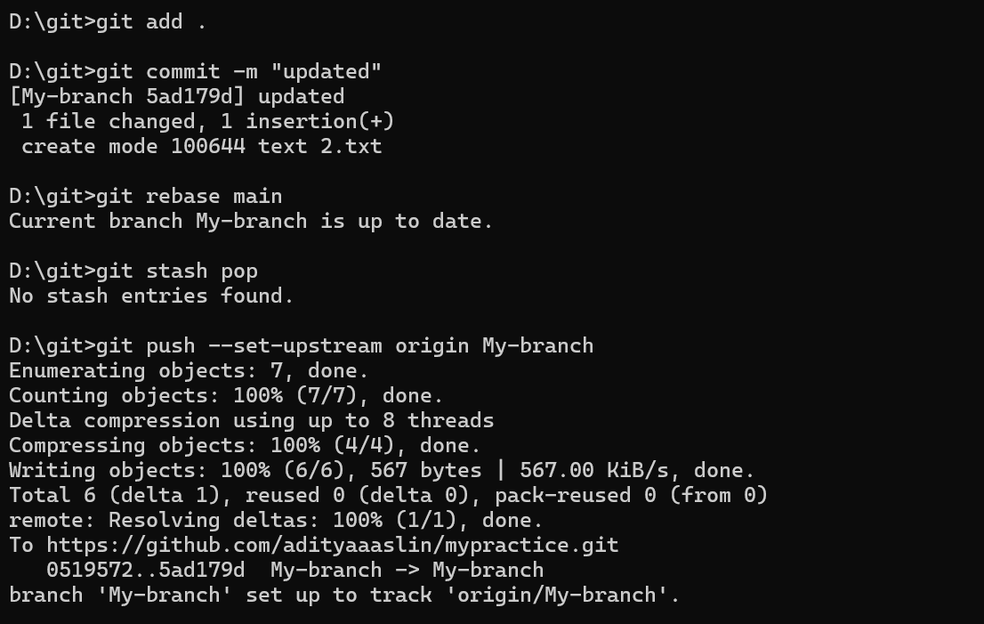

Git Tagging:
The git tag command allows you to "tag" certain points in your repository, often used for releases. Tags are not branches; instead, they are static references to a specific commit that will not move.

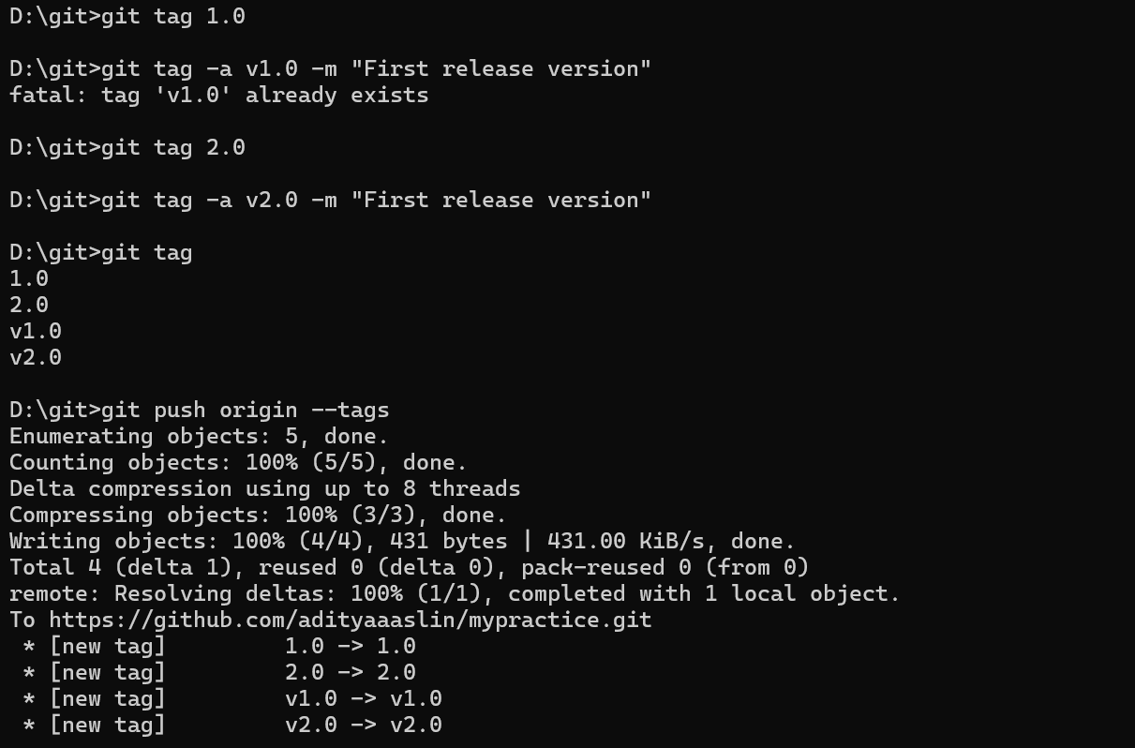

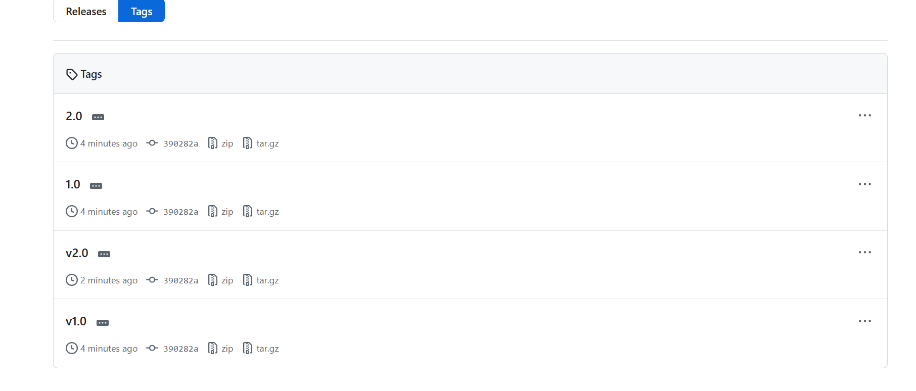

Git reflog:
The git reflog command reveals a log of all the actions taken on your HEAD and branches recently: each time you commit, check it out, rebase, merge, reset and more; even though those actions may not be displayed in git log.
